**Hồ Văn Nhật**

**19T1051013**

**HOMEWORK**

**Exercise 1. Study this information about two courses in electronics. Find three similarities and three differences between these courses.**

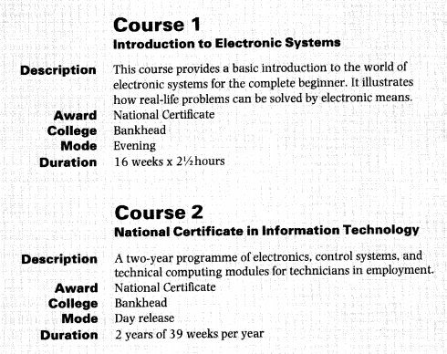

We can describe similarities like this:

1. **Both** courses are Nationally Certified
2. **Like** Course 2, Course 1 provided by Bankhead College.
3. Course 1 **is similar to** Course 1 in that it provided by Bankhead College.

We can describe differences like this:

1. Course 1 is much shorter **than** Course 2.
2. Course 1 is an evening **but** Course 2 is day release course.
3. Course 2 is for techniscians **whereas** Course 1 is for complete beginners.

**Exercise 2. Writing Timetable**

|  |  |  |  |  |  |
| --- | --- | --- | --- | --- | --- |
|  | **Monday** | **Tuesday** | **Wednesday** | **Thursday** | **Friday** |
| 7.00 – 8.50 | specialized math | Electronic measurement | Have breakfast | electromagnetic fields | Have breakfast |
| 9.00 – 10.50 | electronic practice | Listen to music | Microprocessor architecture | Listen to music | Play football |
| 13.00 – 14.50 | Play football | English for electronic and telecommunication | English for electronic and telecommunication | electronic practice | English for electronic and telecommunication |
| 15.00 – 16.50 | electromagnetic fields | home |

**Exercise 3. Find the values and tolerances of resistors banded as follows. Then compare your answers with your partner.**

|  |  |  |  |  |  |
| --- | --- | --- | --- | --- | --- |
|  | Clor 1 | Clor 2 | Clor 3 | Clor 4 | Value |
| 1 | Red | Violet | Orange | Silver | $${27.10}^{3}÷10\%(Ω)$$ |
| 2 | Blue | Grey | Brown | Gold | $$680÷5\%(Ω)$$ |
| 3 | Green | Blue | Red | Silver | $${56.10}^{2}÷10\%(Ω)$$ |
| 4 | Red | Red | Green | ------ | $${22.10}^{5}÷20\%(Ω)$$ |
| 5 | Brown | Black | Orange | ------ | $${10.10}^{3}÷20\%(Ω)$$ |
| 6 | Orange | Orange | Brown | Gold | $$330÷5\%(Ω)$$ |
| 7 | Yellow | Orange | Red | Gold | $${43.10}^{2}÷5\%(Ω)$$ |
| 8 | Brown | Green | Green | ------ | $${15.10}^{5}÷20\%(Ω)$$ |
| 9 | Violet | Green | Brown | Red | $$750÷2\%(Ω)$$ |
| 10 | White | Brown | Red | Red | $${91.10}^{2}÷2\%(Ω)$$ |